**Data Structures and Algorithms**

Lab 7: Linked lists

**Q1):** Write a program that implements the following:

**Functions:**

1. Create () adding the very first node.

**void creating_node(int value)**

**{**

**try**

**{**

**if (start == NULL)**

**{**

**start=new node;**

**start->data=value;**

**start->next=NULL;**

**length=length+1;**

**}**

**else**

**{**

**throw(value);**

**}**

**}**

**catch(int data)**

**{**

**cout<<"Linked list already exist, Please try to add instead of creating linked list"<<endl;**

**}**

**return;**

**}**

1. Add() the method should insert numbers in sorted order.

**void add(int value)**

**{**

**if (length==0)**

**{**

**cout<<"There is no sign of linked list, Try to create linked list first"<<endl;**

**}**

**else**

**{**

**node *temp;**

**temp = start;**

**while (temp->next!=NULL)**

**{**

**temp=temp->next;**

**}**

**node * new_node;**

**new_node = new node;**

**new_node->data=value;**

**new_node->next=NULL;**

**temp->next=new_node;**

**length = length+1;**

**}**

**return;**

**}**

1. Delete() the function should clearly show, with appropriate comments, deleting a

node (if it is present) by enumerating all the elements of the list after deleting the

concerned node, and “not found” if the requested node is not present in the list.

**void deleting(int value)**

**{**

**try**

**{**

**if (length==0)**

**{**

**throw(1);**

**cout<<"Linked list is empty, deleting is not possible"<<endl;**

**}**

**else**

**{**

**node *current, *prev;**

**current = start;**

**while ((current->next!=NULL) && (current->data!= value))**

**{**

**prev = current;**

**current = current->next;**

**}**

**if (current->data==value)**

**{**

**// if it is first node then**

**if (current==start)**

**{**

**start = current->next;**

**}**

**else**

**{**

**prev->next=current->next;**

**}**

**delete current;**

**length=length-1;**

**}**

**}**

**cout<<"Noting to delete"<<endl;**

**}**

**catch(...)**

**{**

**cout<<"Node having value ["<<value<<"] not found, Hence nothing to delete"<<endl;**

**}**

**return;**

**}**

1. Traverse() informs the user of the length of the linked list

**int sized_of_linked_list()**

**{**

**int size=1;**

**node *temp = start;**

**while (temp->next!=NULL)**

**{**

**temp=temp->next;**

**size = size +1;**

**}**

**return size;**

**}**

1. Traverse () simply prints the elements of the list.

**void traverse()**

**{**

**try**

**{**

**if (length==0)**

**{**

**throw(1);**

**}**

**else**

**{**

**node *temp;**

**temp = start;**

**int len=1;**

**while (temp->next!=NULL)**

**{**

**cout<<"["<<len<<"]: "<<temp->data<<" "<<endl;**

**temp=temp->next;**

**len = len +1;**

**}**

**cout<<"["<<len<<"]: "<<temp->data<<" "<<endl;**

**}**

**}**

**catch(...)**

**{**

**cout<<"Linked list is empty, Try create and add then traverse"<<endl;**

**}**

**return;**

**}**

**A main( ) function that:**

1. Text calls upon an external file containing the numbers [1, 3, 7, 99, 101, 103,107] (you can create a text file yourself.
2. creates and populates the linked list with all the elements presented to it in the text file of part (2a)
3. thereafter, the function asks the user a series of actions that he/she would like to continue to perform iteratively up until he/she chooses to stop. Actions are:

(i) add a node

(ii) delete a node

(iii) enumerate the elements of the list

(iv) length of the list

(v) end – stop the process and stores the current linked list in an external file called

“output.txt”

**Code:**

**int main()**

**{**

**ifstream inputFile("sli.txt");**

**if (inputFile.is_open()) {**

**int num;**

**while (inputFile >> num) {**

**if (start == NULL) {**

**creating_node(num);**

**} else {**

**add(num);**

**}**

**}**

**inputFile.close();**

**} else {**

**cout << "Unable to open numbers.txt" << endl;**

**return 1;**

**}**

**int choice;**

**do**

**{**

**cout<<endl;**

**cout << "Choose any single action:" << endl;**

**cout << "[1] Add a node?" << endl;**

**cout << "[2] Delete a node?" << endl;**

**cout << "[3] Enumerate the elements of the list?" << endl;**

**cout << "[4] Length of the list?" << endl;**

**cout << "[5] End and store the current linked list?" << endl;**

**cout<<"-----------------------------------------------------------------------------"<<endl;**

**cout << "Enter your choice: ";cin>>choice;cout<<endl;**

**switch (choice)**

**{**

**case 1:{**

**int input_value;**

**cout<<"Enter the value of node: ";cin>>input_value;cout<<endl;**

**add(input_value);**

**break;**

**}**

**case 2:{**

**int input_value;**

**cout<<"Enter the value of node that you want to delete: ";cin>>input_value;cout<<endl;**

**deleting(input_value);**

**break;**

**}**

**case 3:{**

**traverse();**

**break;**

**}**

**case 4:{**

**cout<<"Length of the single linked list: "<<size_of_linked_list()<<endl;**

**break;**

**}**

**case 5:{**

**saveListToFile();**

**break;**

**}**

**default:**

**cout << "Invalid choice. Please try again." << endl;**

**}**

**}while(choice!=5);**

**return 0;**

**}**

**Output:**

Command Prompt:

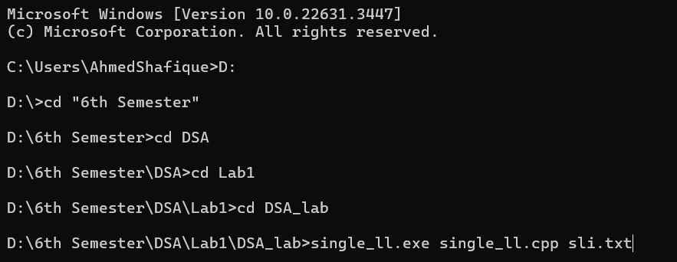

Fig: 01 Programming running on CMD

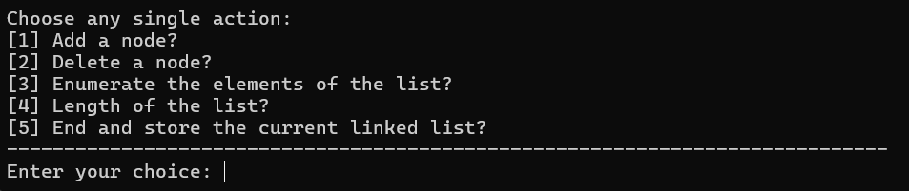

Fig: 02 Accepting Options

Fig: 03 Traversing Linked list

Fig: 04 Adding node

Fig: 05 Deleting node

Fig: 06 Linked lists length

Fig: 07 Saving text file

**Methodology:**

First, we added required header files to run the program which are:

**#include <iostream>**

**#include <new>**

**#include <fstream>**

**using namespcace std;**

The according to the requirement of making structure of linked list we code the structure of linked list which are as follows:

**struct node**

**{**

**int data;**

**node *next;**

**};**

Then we initialize the linked list to zero because there is no sign of linked list initially using following code:

**int length = 0;**

**node *start = NULL;**

We declare them as global because now these can easily calls in any function so there is no need to additionally passed them into function as a argument. Then we coded the creating_node function to create the node as user input text file. Then we coded traverse function, the traverse function prints the value in whole linked list and we set that if there no node then it return nothing and we use while loop and pass the condition that it stops where the next structure pointer points to NULL.

We coded the add function to add additional nodes from the user and then, we coded another function called deleting to delete the node of linked list that user want to delete based on the value of the node input by the user.

We coded **size_of_linked_list** function to calculate the length of linked list, it same as some portion of traverse function but it have one statement different from traverse which is:

**length = length + 1;**

then it returning length using return length;

At last we coded the last part of program in which user can save the linked list data into the output text file. So, We initialize the file input in main function then we pass one condition that if there is no sign of linked list and it initialize to zero then it calls the creating_node function to create the node in the linked list and initialize it to 1. Else it add the nodes in the linked list using add function.

Also we give choice to user to save it linked lists data that the user ran into output text file using ofstream, here is the code below:

**void saveListToFile() {**

**ofstream outputFile("slo.txt");**

**if (outputFile.is_open()) {**

**node *temp = start;**

**while (temp != nullptr) {**

**outputFile << temp->data << " ";**

**temp = temp->next;**

**}**

**outputFile.close();**

**cout << "Linked list saved to output.txt" << endl;**

**} else {**

**cout << "Unable to open output.txt for writing" << endl;**

**}**

**}**

**Data Structures and Algorithms**

Lab: 08 Double Linked lists

**Q1.** Write a program that implements the following:

**Functions:**

1. create(): adding the very first node

**void create (int value) {**

**if (length == 0) {**

**start = new node;**

**start->data = value;**

**start->previous = NULL; // Use nullptr instead of NULL for better clarity**

**start->next = NULL;**

**length = length + 1; // Don't forget semicolon at the end of the statement**

**}**

**else {**

**cout << "List not empty. Try Again." << endl; // Fixed the error message string**

**}**

**return;**

**}**

**b)** add (): the method should insert numbers in sorted order.

**void add(int value) {**

**node* newNode = new node;**

**newNode->data = value;**

**newNode->previous = NULL;**

**newNode->next = start;**

**if (start != NULL)**

**start->previous = newNode;**

**start = newNode;**

**length = length + 1;**

**}**

1. delete () : the function should clearly show, with appropriate comments, deleting a node (if it is present), and “not found” if the requested node is absent.

**void deleteNode(int value) {**

**if (length == 0) {**

**cout << "List is empty." << endl;**

**return;**

**}**

**node* current = start;**

**node* previous = NULL;**

**while (current != NULL) {**

**if (current->data == value) {**

**if (current == start) {**

**start = current->next;**

**if (start != NULL)**

**start->previous = NULL;**

**} else {**

**previous->next = current->next;**

**if (current->next != NULL)**

**current->next->previous = previous;**

**}**

**delete current;**

**length=length-1;**

**cout << "Node with value " << value << " deleted." << endl;**

**return;**

**}**

**previous = current;**

**current = current->next;**

**}**

**cout << "Node with value " << value << " not found." << endl;**

**}**

1. length() : informs the user of the length of the linked list

**int length_of_linked_list() {**

**return length;**

**}**

1. traverse() simply prints the elements of the list either in increasing or decreasing order

**void traverse(bool increasingOrder) {**

**if (length == 0) {**

**cout << "List is empty." << endl;**

**return;**

**}**

**node* current;**

**if (increasingOrder) {**

**current = start;**

**cout << "List elements in increasing order: ";**

**while (current != NULL) {**

**cout << current->data << " ";**

**current = current->next;**

**}**

**} else {**

**current = start;**

**while (current->next != NULL)**

**current = current->next;**

**cout << "List elements in decreasing order: ";**

**while (current != NULL) {**

**cout << current->data << " ";**

**current = current->previous;**

**}**

**}**

**cout << endl;**

**}**

**A main( ) function that:**

1. Text calls upon an external file containing the numbers [1, 3, 7, 99, 101, 103,107] (you can create a text file yourself.
2. creates and populates the linked list with all the elements presented to it in the text file of part (2a)
3. thereafter, the function asks the user a series of actions that he/she would like to continue to perform iteratively up until he/she chooses to stop. Actions are:

(i) add a node

(ii) delete a node

(iii) enumerate the elements of the list

(iv) length of the list

(v) end – stop the process and stores the current linked list in an external file called

“output.txt”

**Code:**

**int main() {**

**ifstream inputFile("sli.txt");**

**if (inputFile.is_open()) {**

**int num;**

**while (inputFile >> num) {**

**if (start == NULL) {**

**create(num);**

**} else {**

**add(num);**

**}**

**}**

**inputFile.close();**

**} else {**

**cout << "Unable to open numbers.txt" << endl;**

**return 1;**

**}**

**// User interaction loop**

**int choice;**

**do {**

**cout << "---------------------------------------------------------------------" << endl;**

**cout << "Dear User " << endl;**

**cout << "Choose an action:" << endl;**

**cout << "[1]. Add a node" << endl;**

**cout << "[2]. Delete a node" << endl;**

**cout << "[3]. Enumerate the elements of the list" << endl;**

**cout << "[4]. Length of the list" << endl;**

**cout << "[5]. End and save to file" << endl;**

**cout << "Enter your choice: ";cin >> choice;cout<<endl;**

**switch (choice) {**

**case 1: {**

**int newValue;**

**cout << "Enter the value to add: ";cin >> newValue;cout<<endl;**

**add(newValue);**

**break;**

**}**

**case 2: {**

**int newValue;**

**cout << "Enter the value to add: ";cin >> newValue;cout<<endl;**

**deleteNode(newValue);**

**break;**

**}**

**case 3: {**

**int order;**

**cout << "Enumerate the elements of the list:" << endl;**

**cout << "1. Deccreasing order" << endl;**

**cout << "2. Increasing order" << endl;**

**cout << "Enter your choice: ";cin >> order;cout<<endl;**

**traverse(order == 1);**

**break;**

**}**

**case 4: {**

**cout << "Length of the list: " << length_of_linked_list() << endl;**

**break;**

**}**

**case 5: {**

**saveListToFile();**

**cout << "Linked list saved to output.txt. Exiting..." << endl;**

**break;**

**}**

**default:**

**cout << "Invalid choice. Please enter a valid option." << endl;**

**}**

**} while (choice != 5);**

**return 0;**

**}**

**Output:**

Command prompt:

Fig:01 Running on command prompt

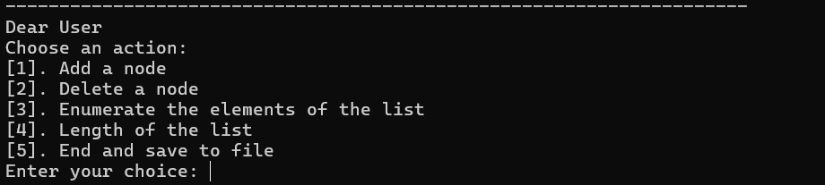

Fig: 02 Accepting user choice

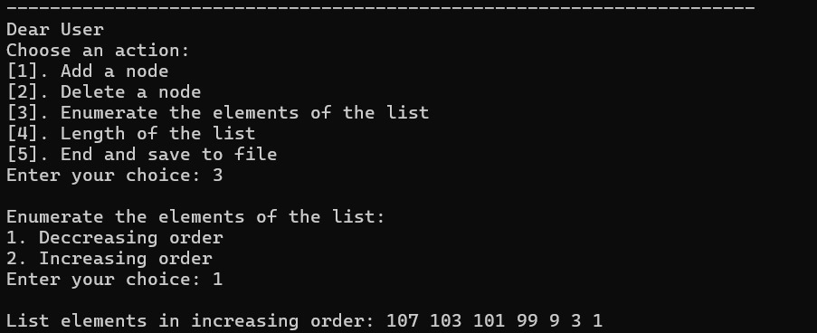

Fig: 03 Traversing decreasingly

Fig: 04 Traversing Increasingly

Fig: 05 Adding node

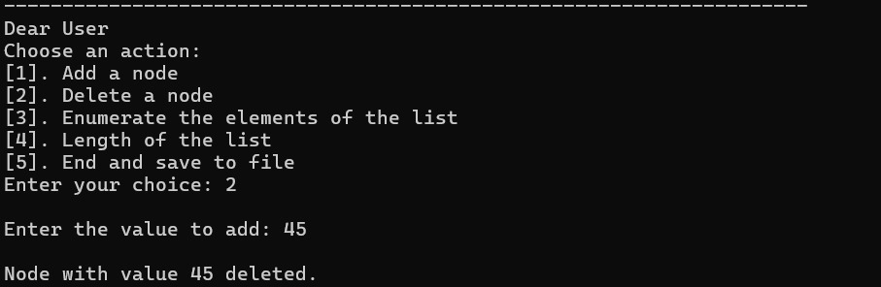

Fig: 06 Deleting node

Fig: 07 Linked lists length

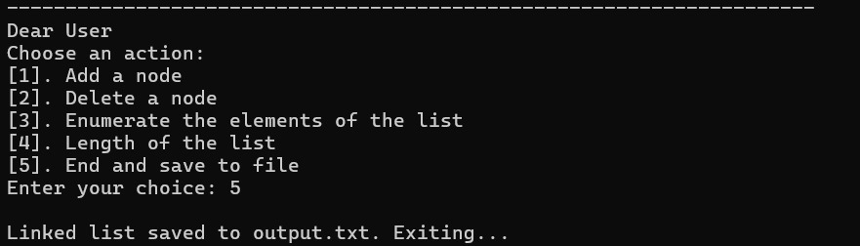

Fig: 08 Saving Output text file

**Methodology:**

First, we added required header files to run the program which are:

**#include <iostream>**

**#include <new>**

**#include <fstream>**

**using namespcace std;**

According to the requirement of making structure for double linked list we code the structure of double linked list which is as follows:

**struct node**

**{**

**int data ;**

**node* previous ;**

**node * next ;**

**};**

Then we initialize the double linked list to zero because there is no sign of double linked list initially using following code:

**int length = 0;**

**node* start = NULL;**

We declare them as global because now these can easily calls in any function so there is no need to additionally passed them into function as a argument. Then we coded the create( ) function to create the node as user input text file. Then we coded traverse( ) function, the traverse function prints the value in whole linked list and we set that if there no node then it return nothing and we use while loop and pass the condition that it stops where the next structure pointer points to NULL.

We coded the add( ) function to add additional nodes from the user and then, we coded another function called delete ( ) to delete the node of double linked list that user want to delete based on the value of the node input by the user.

We coded size_of_linked_list function to calculate the length of our double linked list, it same as some portion of traverse function.

At last we coded the last part of program in which user can save the double linked list data into the output text file. So, We initialize the file input in main function then we pass one condition that if there is no sign of linked list and it initialize to zero then it calls the create function to create the node in the linked list and initialize it to 1. Else it add the nodes in the double linked list using add function.

Also we give choice to user to save it linked lists data that the user ran into output text file using ofstream, here is the code below:

**void saveListToFile() {**

**ofstream outputFile("dlo.txt");**

**if (outputFile.is_open()) {**

**node *temp = start;**

**while (temp != nullptr) {**

**outputFile << temp->data << " ";**

**temp = temp->next;**

**}**

**outputFile.close();**

**} else {**

**cout << "Unable to open output.txt for writing" << endl;**

**}**

**}**